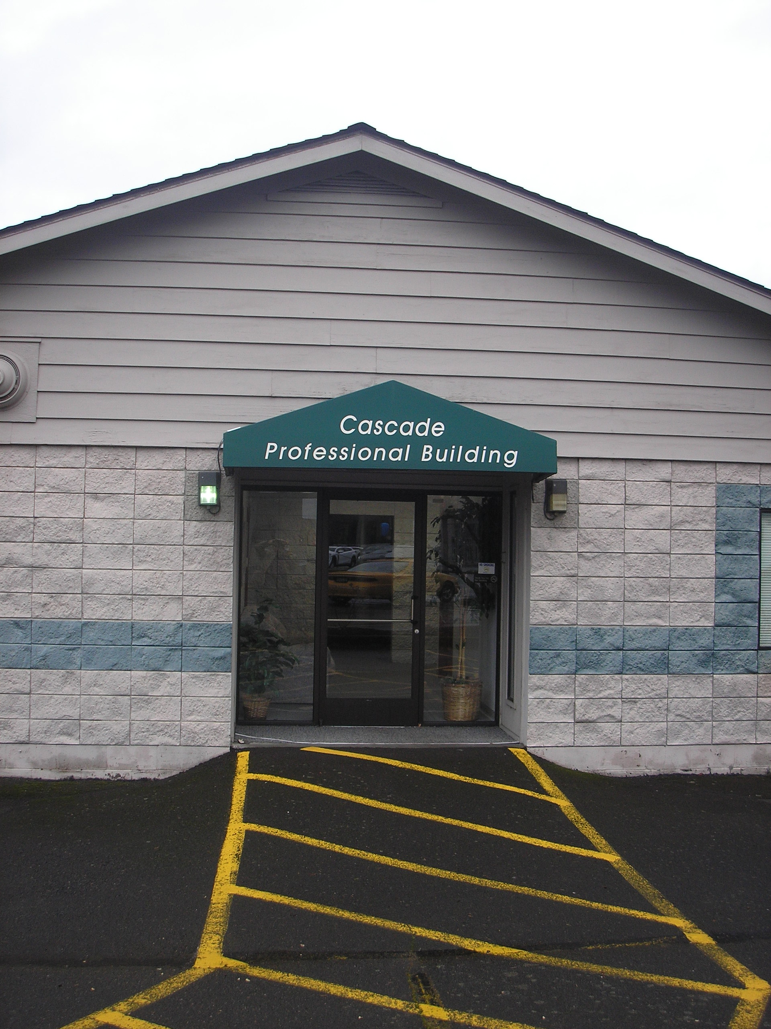


Salem Spirit of Life Church

“A Welcoming Community”
Rev Don Eck—Pastor

Church Phone: 503-689-1436 Sunday Worship 10:00AM
1775 32nd Place NE Suite G
Salem, OR 97301

Email: spiritoflife76@gmail.com
Web: www.salemspiritoflife.org

Bulletin For
January 2016

A Message From The Pastor

Dear Friends,

With the New Year before each of us lie’s a fork in the road…an opportunity to effect what the next year of our life will be like.

I encourage you to look forward with a new sense of hope and excitement. Take time to evaluate the successes and failures of 2015, and use them like textbooks from which to glean wisdom for the future. For the sake of the Gospel, this year dare to dream a little bigger and work a little harder.

For the sake of the ones you call family, choose to laugh a little longer and hold them each a little closer. Only one time will this next year be yours for the living. Do not waste it looking back with longing or with regret.

The wisdom of God admonishes you and shows you your responsibility. As the Apostle Paul so aptly stated it. “But one thing I do. Forgetting what is behind and straining toward what is ahead. I press on toward the goal to win the prize for which God has called me heavenward in Christ Jesus” (Phil. 3:13,14).

As your pastor, I am confident that the Lord has many good things in store for you this year. May this message serve as a reminder to you of the high calling that rests on you as a child of God and the wonderful privilege you have to make the most of the upcoming year.

Peace, Joy and Love

Pastor Don

Volunteer’s are always needed to help with Church growth. January is a good time to review the volunteer needs of the Church.

Here is a list of areas that volunteers are always needed:

Hospitality – Arriving early to make coffee and arrange for treats following worship.
Organizing our Pot Luck and Movie nights – 3rd Friday of the month.

Leaders: Bible Study Groups

Music: Musicians and Singers

Social Action: Keep members abreast of the ongoing social needs in our area.

Readers: To read Scripture during the Worship Service.

Fund Raising: Someone to organize and lead us in fund raising events.

Tithing: Jesus said, “Where your treasure is, there will your heart be also>” (Matt. 6:21). Where you spend your money does make a difference. It makes a difference in your outlook. It makes a difference in your insight. Perhaps you need to do something specific to improve your spiritual vision. This church recommends percentage giving as one more means of properly focusing all of life on the Lord who gives us all things. Have you made a covenant with God to give Him a specific percentage of all that comes into your hands.
Mark Your Calendar:
Jan 15th Movie and Pot Luck
Jan 31st We Celebrate St. Blaise Feast with a Blessing of Throats during our Worship Service
Feb 10th Ash Wednesday
Feb 19th Movie and Pot Luck
Mar 13th Daylight Saving Time Begins
March 20th Palm Sunday
March 24th Holy Thursday
March 25th Good Friday
March 27th Easter Sunday

The HIV Alliance Meets at the Church 2nd Tuesday of every month at 4:30PM

If you would like to be a Sunday morning Host or Reader at Worship Service please signup on the calendar in the hospitality room.

